**Report on**

**Weather Data**

**Importing Libraries :**

Import the required libraries for data analysis in python in jupyter.

Import Pandas for accessing the dataset.

Import Matplotlib for visualization of the data.

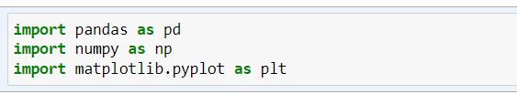

**Converting the csv file to a Data Frame :**

Using pandas Reading the csv file into jupyter notebook and converting it into a Data frame.

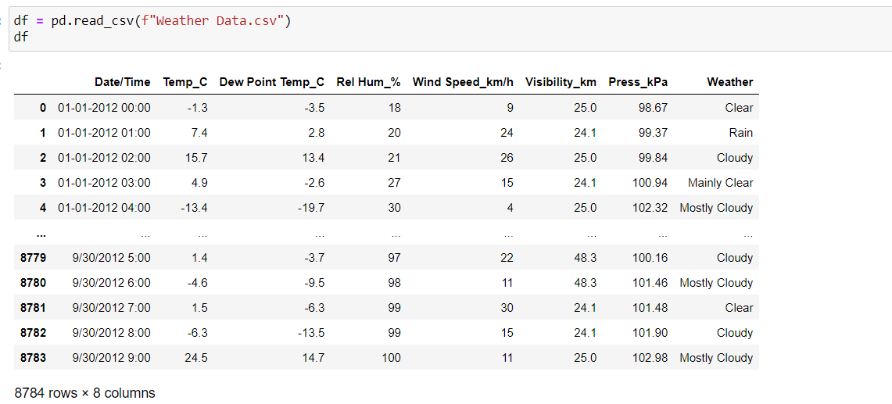

* **Iterating on the Data Frame as per the Problem Statement**

**Q. 1) Find all the unique 'Wind Speed' values in the data.**

**Ans)** 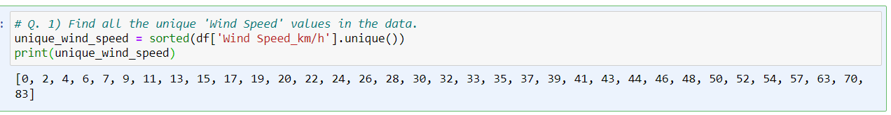

**Explanation :**

This code will extract the 'Wind Speed' column from your weather DataFrame and then use the unique() method to find all the unique values in that column. The unique wind speeds will be stored in the unique_wind_speeds variable and printed to the console.

**Q. 2) Find the number of times when the 'Weather is exactly Clear'.**

**Ans)**

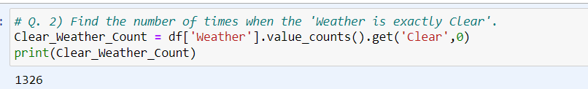

**OR**

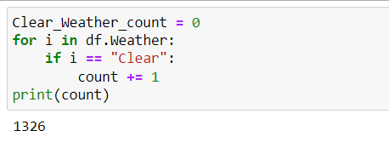

**Explanation :**

This Code will extract the ‘Weather’ column from the Data Frame and count the number of instances where the value is specified as ‘Clear’ and stores it in the variable ‘Clear_Weather_Count’ and prints it to console.

**Q. 3) Find the number of times when the 'Wind Speed was exactly 4 km/h'.**

**Ans)**

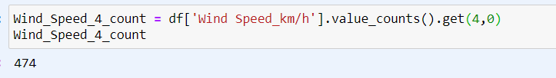

**OR**

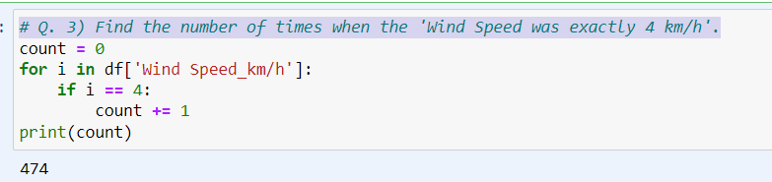

**Explanation :**

This code extracts the ‘Wind Speed ’ column from the Weather Data Frame and counts the number of times 4 has occurred in the column and prints the count of it.

**Q. 4) Find out all the Null Values in the data.**

**Ans)**

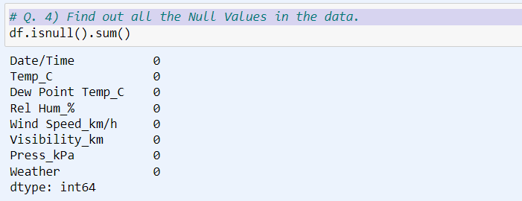

**Explanation :**

This code finds out all the null values present if any in the Data Frame.

**Q. 5) Rename the column name 'Weather' of the dataframe to 'Weather Condition'.**

**Ans)**

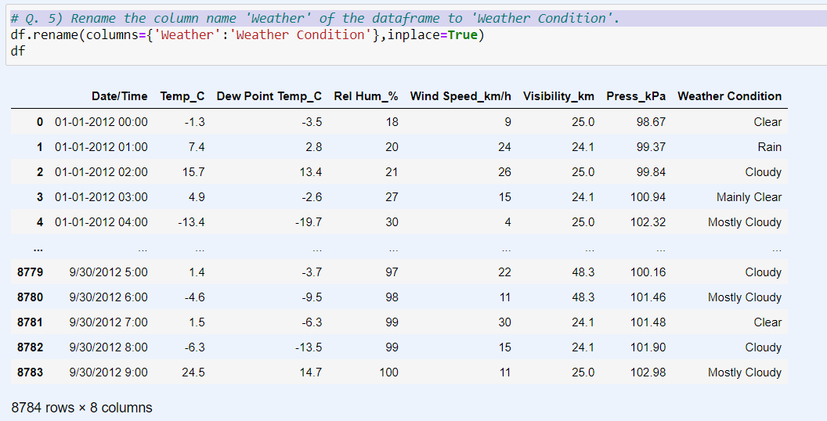

**Explanation :**

After running this code, the column name will be changed from 'Weather' to 'Weather Condition' in your Data Frame and inplace = True parameter will change it in the original Data Frame.

**Q. 6) What is the mean 'Visibility' ?**

**Ans)**

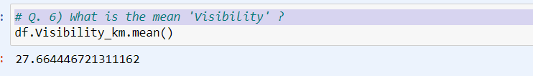

**Explanation :**

This Code calculates the mean (average) value of the 'Visibility_km' column and prints the result.

**Q. 7) What is the Standard Deviation of 'Pressure' in this data?**

**Ans)**

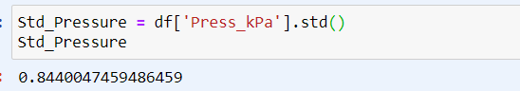

**OR**

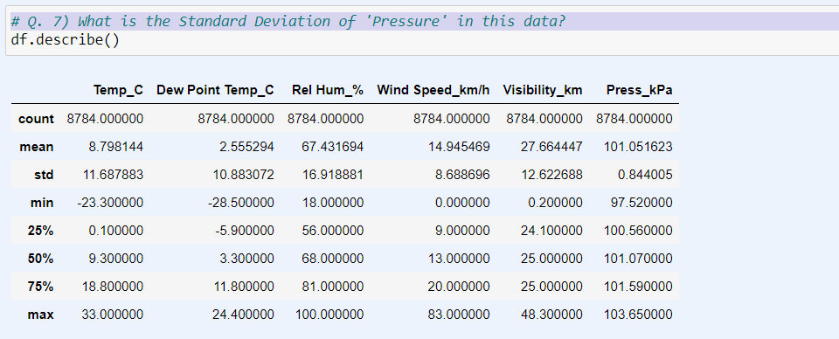

**Explanation :**

This code calculates the standard deviation of the 'Pressure' column and prints the result. Check the names of columns in the data frame should match that of in the code.

**Q. 8) What is the Variance of 'Relative Humidity' in this data ?**

**Ans)**

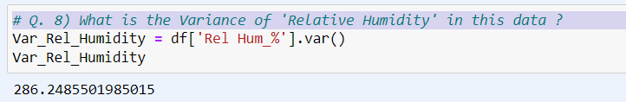

**Explanation :**

This code calculates the variance of the 'Rel Humidity' column and stores it in a variable named Var_Rel_Humidity and prints the result.

**Q. 9) Find all instances when 'Snow' was recorded.**

**Ans)**

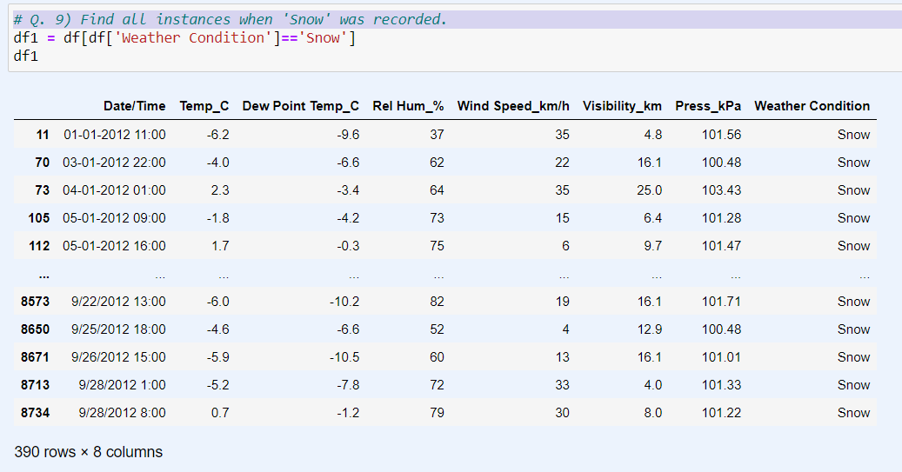

**Explanation :**

This code filters the Data Frame to only include rows where the weather condition is "Snow" and then prints out those records.

**Q. 10) Find all instances when 'Wind Speed is above 24' and 'Visibility is 25'.**

**Ans)**

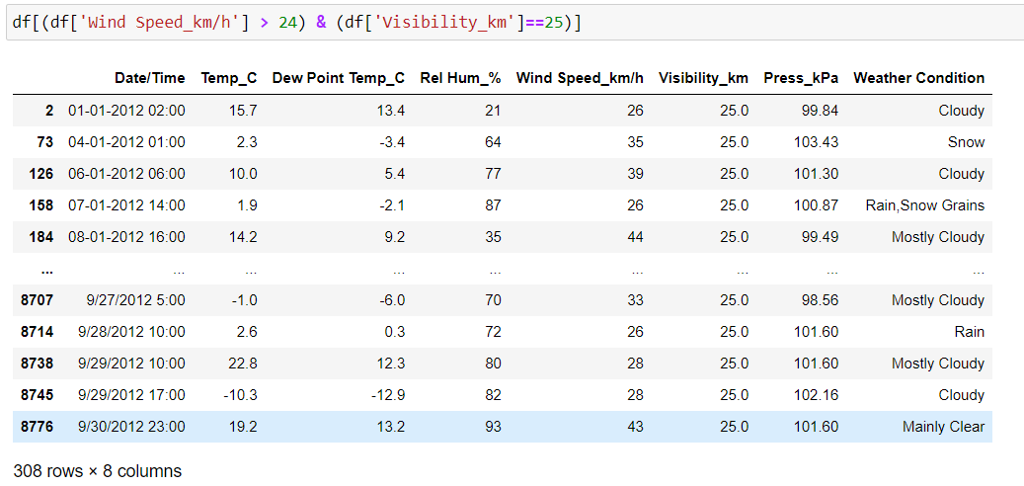

**Explanation :**

This code filters the Data Frame to only include rows where the ‘Wind Speed’ is greater than 24 and ‘Visibility’ is 25, and then prints out those records.

**Q. 11) What is the Mean value of each column against each 'Weather Condition ?**

**Ans)**

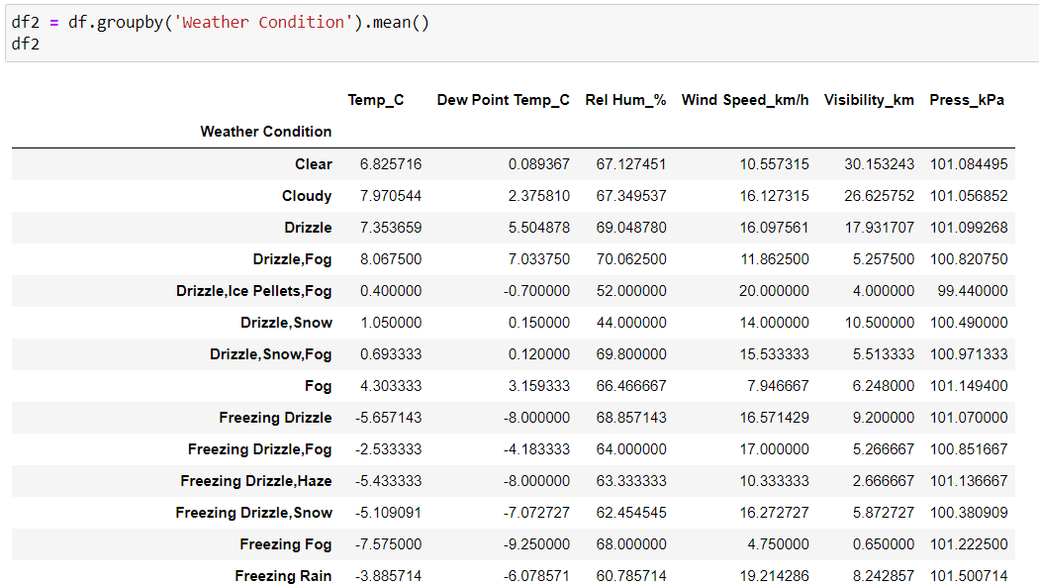

**Explanation :**

This code groups the data by the 'Weather Condition' column and calculates the mean for each condition across all numerical columns in the dataset.

**Q. 12) What is the Minimum & Maximum value of each column against each 'Weather Condition ?**

**Ans)**

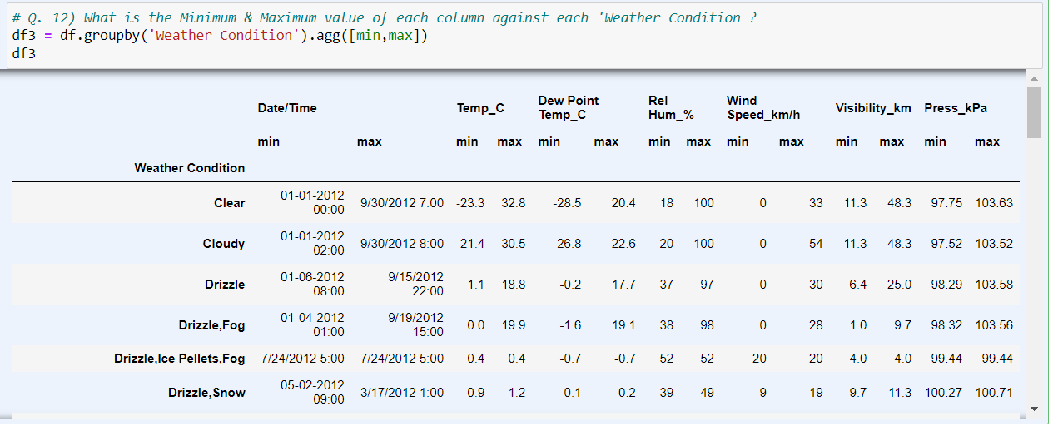

**Explanation :**

This code will group the DataFrame by 'Weather Condition' and then calculate the minimum and maximum values for each group.The resulting DataFrame result will display the minimum and maximum values for each column for each 'Weather Condition'.

**Q. 13) Show all the Records where Weather Condition is Fog.**

**Ans)**

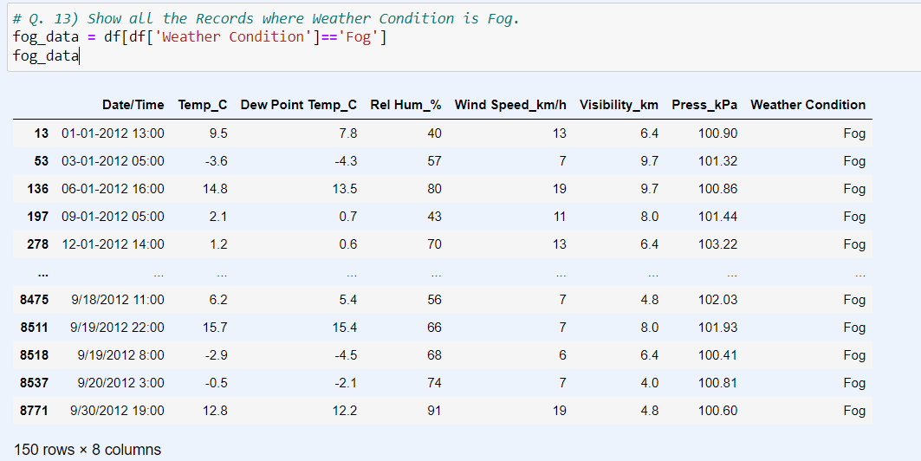

**Explanation :**

This code filters the DataFrame to include only rows where the 'Weather Condition' is 'Fog' and then prints out those records.

**Q. 14) Find all instances when 'Weather is Clear' or 'Visibility is above 40'.**

**Ans)**

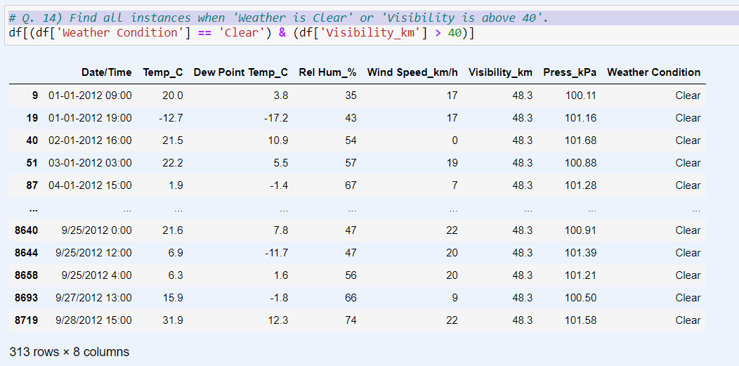

**Explanation :**

This code creates a condition where it checks if the 'Weather Condition' is 'Clear' or if the 'Visibility_km' is greater than 40. It then applies this condition to the DataFrame and prints out the filtered records.

**Q. 15) Find all instances when**

**A. 'Weather is Clear' and 'Relative Humidity is greater than 50'**

**or**

**B. 'Visibility is above 40'**

**Ans)**

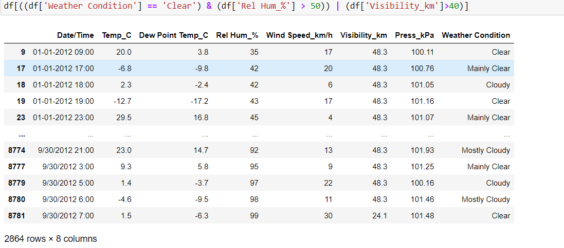

**Explanation :**

The result will contain the rows that satisfy either condition A or condition B or both.